Saltbox

CareLink Service Evaluation

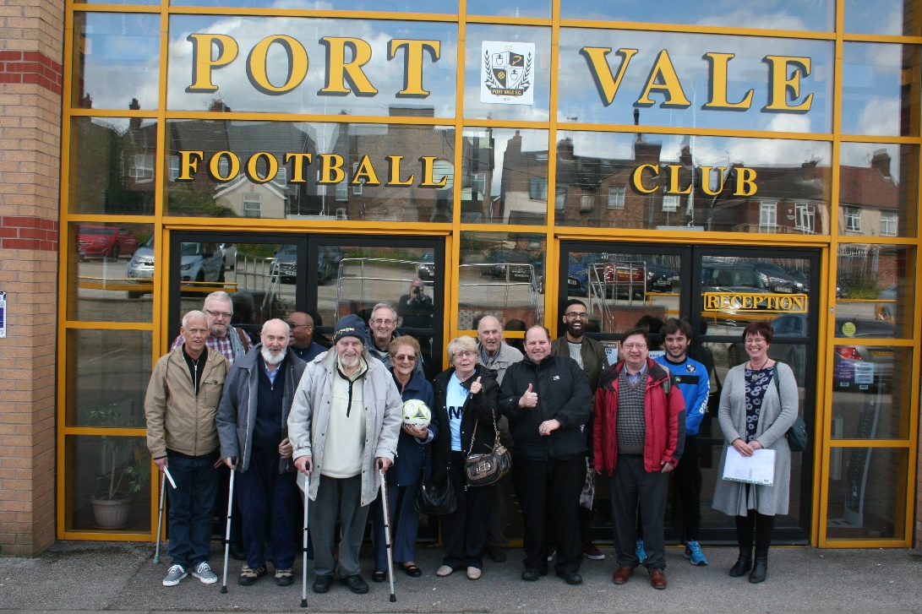

Report

30 June 2017

The Social Enterprise and Community Regeneration Specialists

Commission
Client Reference: C-SAX-720
Client: Saltbox
Title: CareLink Service Evaluation

Document
Document Number: 1
Type: Draft Report
Date: 30 June 2017

Quality Assurance
Report Checked by: Managing Director
Signature:

Date: 30 June 2017

Pulse Regeneration Limited, Graeme House, Derby Square, Liverpool L2 7ZH
t 0151 475 7000 f 0151 475 3000 e info@pulseregeneration.co.uk w www.pulseregeneration.co.uk

© 2017 Pulse Regeneration Ltd. No responsibility for loss or damage occasioned to any person acting or refraining from action as a result of any statement in this report can be accepted by Pulse Regeneration Ltd.
Contents

1 Introduction 4
1.1 Terms of Reference 4
1.2 Report Objectives 4
1.3 Approach 4

2 Saltbox 5
2.1 Background 5
2.2 Services 5

3 CareLink Service 6
3.1 Overview 6
3.2 Understanding Need 6
3.3 Delivery Activities 7
3.4 Outcomes 8
3.5 Need for an Evaluation 9

4 Making a Difference 10
4.1 Achievement of Original Outcomes and Targets 10
4.2 Broader Successes and Targets 11
4.3 Benefits for Service Users 11
4.4 Benefits for Volunteers 14
4.5 Theories of Change 18
4.6 Unintended Benefits 19

5 Ongoing Need 21
5.1 Continuing Demand 21
5.2 Changing Local Need 22
5.3 Implications for the Future 22

6 Lessons Learnt 24
6.1 Good Practice 24

7 Future Delivery 26
7.1 Continuing the Support 25
7.2 Further Added Value 25
7.3 Maximising Social Value 25
7.4 Moving Forward 26

1 Introduction

1.1 Terms of Reference

Pulse Regeneration was asked to update the CareLink evaluation by Saltbox in February 2017 as part of wider work being undertaken with the organisation. The Update evaluation follows an evaluation undertaken by Pulse Regeneration in February 2014 to evidence the value of the service and consider what further benefits could be achieved from the ongoing operation of the service.

1.2 Report Objectives

The objective of this report is to collate existing information and knowledge into a single point of reference that responds to four key evaluation questions:

- How is the service making a difference?
- What is the need for the service?
- What are the key lessons learnt?
- What could be improved through future development?

It is the intention that this resource enables Saltbox staff and trustees to understand the impact of the service and the ways in which it has improved quality of life, and also to consider how best to continue the service in moving forward. This will help any future funding bid for the service.

1.3 Approach

The approach was agreed in advance with senior representatives of Saltbox. The approach has included a review of existing information, working with Saltbox staff to consider qualitative factors, and collation of the research findings into this evaluation report.

2 Saltbox

2.1 Background

Saltbox was established in 1983 and is a company (number 6427360) and a registered charity (number 1121832). Its purpose was to promote Christian values and faith, and to unite individual churches. Having developed successfully for over 30 years, Saltbox now encourages and helps build the capacity of communities to be able to inform and influence local decision making and services to bring about beneficial change in communities, as well as developing and connecting with local, regional and national networks to support encourage and share best practice.

Increasingly Saltbox is invited to represent faith communities by various secular bodies and partnerships both at a local and regional level, and is seen by many partners as a key specialist infrastructure organisation. Saltbox has also developed its social responsibility work and now runs a range of successful projects that seek to care for vulnerable local people.

Saltbox operates in communities across Cheshire East, Cheshire West & Chester, Staffordshire, and Stoke-on-Trent City.

Saltbox currently has seven trustees in place.

The accounts for 31 December 2016 indicate a total income of £1,159,156 against spending of £1,262,812.

2.2 Services

Aside from faith based activities, Saltbox provides a broad range of services for the benefit of local people:

- CareLink – Working to improve the health and wellbeing of older people through combatting social isolation and loneliness.

- Restart – Provides hope and support for ex-offenders as well as a safe place to deal with life's challenges whilst positively looking towards the future.

- Community Engagement – Older People’s Engagement Network (OPEN) actively encourages, promotes and helps to sustain social action initiatives that bring about beneficial change to our 50+ community.

- Money Matters – Free and confidential service for anyone with debt issues or money worries provided exclusively at point of need via Trussell Trust Foodbanks

- Retirement Transition Initiative (RTI) – community and corporate workshops helping people prepare for the transition into a meaningful and fulfilling retirement

3 CareLink Service

3.1 Overview

CareLink and its predecessor services have been successfully guiding older people out of isolation and loneliness for over eight years. Over this period there have been many changes stemming from continuous improvement activities and funding arrangements. The project emerged from a Stoke-on-Trent Faith Action Audit, a faith-oriented analysis of community sector activity and need, pioneered by Saltbox, which identified a clear prevalence of loneliness and isolation amongst older people. In addition, there was a lack of services in the city, leading Saltbox to develop the project, known as ‘PhoneLink’ via match funding from charitable trusts.

The initial success of the project led to a focus on wider engagement, including home visits and outreach work with older people’s community groups. The work also clearly exposed a further gap in local provision leading Saltbox to partner with a specialist in bereavement support and counselling, The Dove Service. It was then that CareLink attracted Big Lottery Funding (BLF), enabling it to mature into a fully established and reputable health and social care project.

Because of the BLF grant CareLink was able to open discussions with Stoke-on-Trent Clinical Commissioning Group (CCG) regarding the viability of NHS grant funding. Following evaluation, the CCG agreed to fund CareLink for an initial 15 months, with a ‘tiered’ service model, focusing on prevention, early intervention and health outcome targeting. Because of the successful delivery within the first 15 months, the CCG took the decision to extend the funding for another year.

CareLink has subsequently progressed over the last two years into a multi-component, tailored, tiered service, where provision varies depending on the beneficiary’s needs and the solutions agreed between staff, the individual and their support network. The service has also developed its approach towards ‘social prescribing’, signposting and partnership working, meaning that CareLink acts as a key resource from which people can link to community initiatives, amenities and facilities, ranging from GPs to lunch clubs to convenience stores, and more.

By the end of its first full year of service as the new model (funded by the CCG up to March 2016), the service had 147 live clients. At the end of 2016/17 the caseload had grown to over 200 whilst both referrals and sign-ups to the service increased more than threefold. The service’s volunteer base of 21 people made over 16,000 befriending phone calls, giving over 4,000 hours of their own time over the year. In addition, for 2017 CareLink is running a bespoke Volunteer Co-ordinator project, helping to source enough volunteers to meet the increasing demand.

3.2 Understanding Need

In developing the CareLink proposal, extensive research and consultation was undertaken to identify local need and confirm what form of provision would best meet this need. In outline, this included:

- Development Worker Feedback – Saltbox’s previous Development Support team through their generic engagement activities reported current older people’s issues such as experiencing extreme loneliness, chronic isolation of not seeing or talking to another person for a week or more, lack of confidence due to falls, illness or bereavement, as well as a lack of social involvement.

- Liaison Through Established Local Community Networks – This enabled older people to share their views on the services they and their peers would most value, in their known, trusted, and familiar environments. This included engaging with older people’s groups, as well as through open dialogue with CareLink clients and volunteers.

- Consultation Events – Consultation held with service users and volunteers to understand how future delivery could be maximised and outcomes for older people enhanced.

- Strategic and Third Sector Liaison – Rolling dialogue with statutory and voluntary community sector organisations to provide a diverse range of views, needs and solutions.

- Statutory Sector Policy – Discussions with policy and decision-makers in the local public sector assisted the proposals to align fully with a range of local strategies, including; ‘Ageing Well, Living Well’, the Carers Strategy, the Dementia Strategy, the Falls Strategy, the Mental Health Strategy the Older People's Strategy, the Affordable Warmth Strategy, as well as the Community Engagement Strategy.

3.3 Delivery Activities

Based on a thorough understanding of local need and having established strong networks with older people, CareLink delivers a range of targeted activities including:

- A telephone befriending service helping to reduce social isolation and promote healthy and independent living. Operates 365 days-a-year providing regular calls from trained volunteer befrienders and staff, with the frequency of calls being determined by the client from daily to once a week. When and where possible, clients are contacted by the same person so that they recognise a friendly voice and build trust and confidence in the relationship.
- Tiered/tailored support. As part of CareLink’s referral pathway and ongoing support, beneficiaries are grouped into Tiers One (for lower level needs) and Tier Two (for entrenched needs which require multi-agency, professional support).
- Tier One beneficiaries receive regular befriending calls, advice and guidance and have a support review with a staff member at least every six months. Tier Two beneficiaries are those who are suffering more acutely with their health and wellbeing, due to for example;
  - A recent spell in hospital and subsequent recovery
  - An ongoing health problem or increased impact of conditions such as dementia
  - A recent bereavement or similar family crisis
  - Particular difficulties with housing, neighbourhood, money or similar issues which accentuate vulnerabilities
- Tier Two involves more intensive support, such as face-to-face meetings involving other stakeholders (including family), accompanying individuals to appointments or on errands, and supporting with medication or self-care. These activities target beneficiaries in a preventative way in order to reduce and alleviate the impact of poor health and wellbeing.
- Beneficiaries move between Tiers depending on their need, in recognition that their situations often fluctuate, sometimes on a daily basis. Befriending calls act as a way for staff to keep track of their wellbeing, enabling us to act in their best interests, at short notice, whatever their circumstances.
- Volunteering opportunities. Supporting people of all ages, either on their journey to improved confidence and wellbeing, or on the pathway into paid employment. Many of the volunteers faced similar issues to the CareLink customers, such as isolation, low self-esteem, or mental health issues.
- Strategic partnership working. Working in partnership with both statutory and other voluntary sector providers to influence strategy, inform service delivery, and raise awareness of pertinent issues to encourage transformational change in older people's services.
- Heritage trips and events. Days out to local attractions and heritage sites such as Royal Stafford, Westport Lake, Gladstone Pottery Museum, Port Vale Football Club, Emma Bridgwater, Stoke City Football Club, etc thus promoting social integration, confidence building and emotional wellbeing for both customers and volunteers.

3.4 Outcomes

To help identify progress and achievement against the service outcomes, a range of key performance indicators (KPI) were established. These are summarised for reference below:

Outcome
Outcome
As part of the service delivery, 700 vulnerable, lonely and isolated older people will be supported to maintain independent living, healthier lifestyle and report feeling less isolated
KPI | Detail
1 | Total number of vulnerable, frail and older people supported to maintain independent living and healthier lifestyle.  No. of new CareLink clients total 700
2 | No. of CareLink clients Tier 2: 350
3 | No. of volunteers recruited: 40
4 | Amount of money saved via CareLink interventions (not specified at the outset but has become the single most important performance indicator)

3.5 Need for an Evaluation

At the outset, it was acknowledged by all parties that although the original funded CareLink project had a finite timescale, once the service ended older people would continue to experience need related to isolation and loneliness. Saltbox originally anticipated that Stoke-on-Trent City Council support may be gained to continue the service, or that additional funding could be secured, which it has been through the Clinical Commissioning Group. Further funding is now sought to not just continue the service but to support a greater number of older people in order that a growing older population and ever increasing demand can be satisfied.

It is the intention that this evaluation will document the achievements of the service and help not only secure future investment, but also identify where any future improvements may be possible to better meet local need in moving forward.

4 Making a Difference

4.1 Achievement of Original Outcomes

The outcomes and the achievement of their associated KPIs at the end of the service are summarised below:

Outcome
By the end of Year 2 700 lonely and isolated older people will be supported to maintain independent living, healthier lifestyle and report feeling less isolated
KPI | Description | Target | Achieved
 |  | # | # | %
1 | Total number of lonely and isolated older people supported to maintain independent living and healthier lifestyle | 700 | 343 | 49%
2 | No. of CareLink clients – total – Tier 2: 350 | 350 | 110 | 31%
3 | No. of volunteers recruited | 40 | 45 | 112%
4 | Amount of cost saving made to health services as a result of CareLink service | N/A | £627k | N/A

For ease of reference, overall achievement may be summarised below using a simple colour coding system, whereby green represents 100% achievement or greater and amber indicates 99% achievement or less:

Achievement
KPI | Description | Achieved | Detail
1 | Total number of vulnerable, frail and older people supported to maintain independent living and healthier lifestyle | 49% | 357 under target
2 | No. of CareLink clients Tier 2 – target 350 | 31% | 220 below target
3 | No. of volunteers recruited | 112% | 5 over target
4 | Amount of cost saving made to health services as a result of CareLink service | £627,000 | No target set at the start

The amber levels are due to high targets being set at the start of the service. It was a new area of delivery to CareLink to be delivering support for Tier 2 older people. There has also been a period of mobilisation to get the right staff into post, which was not accounted for in the service design. In terms of achievements, the service is proving very good value for money, with a good return on the investment made: for a total CCG expenditure of £278,664 in the two years to March 2017, the estimated cost saving delivered was £627,000. This is more than £2 for every £1 spent, with the savings ratio increasing each month as the service matures.

4.2 Broader Successes and Targets

Aside from the outcomes and KPIs as set out above, ongoing performance monitoring and internal evaluation has shown that the service has achieved the following:

- 100% of volunteers enjoy their role volunteering with CareLink
- 100% of volunteers feel they are treated with respect by staff and other volunteers
- 100% feel that CareLink is a good organisation to volunteer with
- 47% of volunteers felt that they are getting work experience from volunteering with CareLink; the same felt they have improved their career prospects as a result of the volunteering (the rest were happily retired and did not need work experience)
- 73% of volunteers felt CareLink has helped them to build team working skills
- 87% of volunteers felt CareLink has helped them to develop organisational skills
- In addition to supporting the service users and volunteers, family members of those referred to CareLink have also felt the impact and been supported by the service.
- 98% of clients said the befriending made them feel less lonely & isolated
- 99% clients said they were happy with the quality of their calls

4.3 Benefits for Service Users

Service users have been shown to gain an incredible amount from the service, especially in terms of coping with anxiety, reducing depression, reducing feelings of loneliness and increasing social interaction – all improving quality of life. The impact of the service can be seen from the case studies of a number a service users.

Case Study 1
Service User
- Woman in her early 70s
- Suffering with depression and anxiety
- Allocated 3 befriending calls per week
- Referral from Community Psychiatric Nurse

She lives with her husband and has ongoing struggles with anxiety & depression, as well as asthma and COPD. She was referred to CareLink by her Community Psychiatric Nurse who supports her when needed.

During initial assessment, J and her husband expressed concern that she had overdue appointments at the memory clinic, which she had not attended due to her anxiety about leaving the house. CareLink were able to liaise with the clinic, CPN and GP to clarify that she did not need to be under the memory clinic, but could be referred back to her CPN via her GP when needed. This provided clarity and reassurance to her and her husband.
After about 3 months of calls during which time trust was built up with J and her husband, J phoned in very distressed to inform us she and her husband had been the victims of a scam. They were reluctant to contact the police, but her husband was so distressed that he was expressing suicidal thoughts. CareLink contacted the police who were initially somewhat dismissive, however after a number of conversations with CareLink, they went on to support the couple and help them to resolve the issue. J and her husband were incredibly grateful to CareLink for their support.

A few weeks later CareLink discovered that J was overdue attending an appointment at the warfarin clinic. She had been having treatment by injections but this was causing her some problems. However due to her anxiety she had not left the house for some months. Her husband asked CareLink to support them to get her to the appointment. Through building up trust in CareLink through previous events and calls, with a lot of encouragement, and support on the day, the CareLink officer attended the appointment with them. Her treatment was changed from injections to tablets, which work much better.

CareLink is currently working with J and her husband to encourage them to attend one of the Service’s Heritage trips to help them develop social networks and for J to build up further confidence about leaving the house and mixing socially.

Case Study 2
Service User
- Man in his early 70s
- Struggling with anxiety and loneliness
- Self-referral

Referred himself to CareLink as he was struggling with anxiety and wanted support over a personal situation. His partner of 16 years is in a nursing home due to having dementia. Her family had expressed concerns over his relationship with her and as a result he is no longer allowed to see her. Through getting to know him, it is clear that this has left a massive hole in his life, and although he is physically active and attends regular away football matches, he is very lonely and becomes easily upset.
Through CareLink calls it became clear that the best approach was to steer the conversation away from his partner and focus on the good things in his life, as it appears little can be done about his partner. His partner sadly no longer recognises him, and he is currently attending Dove counselling to help deal with his grief.

At initial assessment, a number of issues were identified with his house, and referrals were made to mend a broken window, mend his broken boiler so he could get hot water again and have new smoke alarms fitted. These are all now resolved.

Recently D was encouraged to attend one of our Heritage trips; initially he was unsure, however when CareLink discovered that his grandfather had been a chairman at Port Vale football ground CareLink encouraged him to attend the trip there. He was able to share memorabilia and stories with others attending the trip, which helped him to grow in confidence and boosted his self-esteem. He was later encouraged to talk to a local paper who ran his story.

Through the trust built with CareLink, D has since raised various personal issues of concern with the CareLink befrienders, and CareLink officers followed up with support. He recently fell and hit his head, attending A&E for stitches. He was anxious about returning home so CareLink agreed to offer several extra calls to check on him. This gave him reassurance about returning home while recovering from the injury. When one of these calls was missed CareLink contacted the police and a PCSO did a welfare check to ensure he was ok.

On another occasion D locked himself out. CareLink was able to help him locate a locksmith to sort the problem, and to arrange for a neighbour to hold a spare key for him in case of a repeat, in order to save the cost of a locksmith in future.

D is generally able to look after himself but finds the reassurance of knowing he can come to Carelink for support when needed has a really positive impact on his mental health and quality of life.

Case Study 3
Service User
- Man in his early 90s
- Referral from the Stroke Association
- Started with 2 calls per week

L is a 93-year-old man who until last year was very independent despite having suffered several cancer diagnoses over the last few years. He had a varied professional career and has led a very active and interesting life. However, last year he suffered a stroke, which has left him with deficits, which mean he can no longer drive or go out by himself due to mobility and sight issues.

The Stroke Association referred L to CareLink as he was really struggling with his mental health due to loneliness and isolation. Although he has 2 children, one has serious health issues and the other lives some distance away. His granddaughter offers some support but has a busy and demanding job so is limited in what she can offer.

At initial assessment, CareLink agreed to start 2 calls per week, and identified a number of practical issues which needed to be resolved; CareLink liaised with other services involved and agreed who would do which piece of work.

L was encouraged to attend one of the Heritage trips and really enjoyed getting out and mixing socially -he talked about it for weeks after to his befrienders. He was later able to attend another trip at which he struck up a friendship with another service user, and they swapped numbers and have since been supporting each other by phone.

L was asked to speak on the radio about the CareLink service and the Heritage trips. During the interview, he said it made all the difference knowing that someone cared and was interested. He knows that if he has any problems he can contact the service for help, and that greatly reassures him.

Case Study 4
Service User
- Man in his early 70s
- Referral from a social worker

J is a man in his early 70s who initially came onto the CareLink service when his wife, who he was caring for, had moved into a long term nursing home. He was struggling badly with this situation but did not engage very well with the CareLink service as was out visiting his wife a lot so the case was closed.

Since then his wife sadly passed away and he has clearly struggled to come to terms with his loss. He was referred back into the service by his social worker, and has engaged with the service this time and found it extremely helpful in many ways. The biggest impact was coming on our Heritage trips to Royal Stafford in Feb 2017. He had not been very sociable before, so was nervous, but got chatting to another client on the minibus who had been through a similar thing, which helped him to feel less alone. The trip opened his eyes and encouraged him to make a fresh start. He has now moved into a retirement village where he attends social events during the week and is shortly going on his second holiday with friends. His confidence has grown and he now looks forward to meeting/talking to new people and seeing different places. He is no longer feeling isolated and is likely to step down from the service in a planned way.

Case Study 5
Service User
- Woman in her late 70s
- Reduced the calls from 3 to 1 per week
- Suffering with anxiety

Woman in her late 70’s who joined CareLink in Jan 2017. She was suffering with anxiety and wasn’t able to leave the house. She was initially put on Staff Only call to build her confidence. She has been able to develop a trust where now she has been going on little trips out with her family and enjoys her garden. She now talks to our volunteers and enjoys the calls just as much. She said that she can’t thank us enough for everything we have done, we have changed her life. She has now been able to reduce from the initial 3 calls a week to just one a week.

4.4 Benefits for Volunteers

Volunteers benefit from CareLink in a number of ways, providing a diverse range of improvements for them as individuals. The specific benefits differ between volunteers, based on aspects such as their age, aspirations, and experience of supporting others, as well as more personal factors such as confidence or life experiences. Broad benefits experienced across most volunteers may be evidenced as including:

- Developing a Work Ethos – Learning how to structure a work ethic can be extremely important, such as having to respond to regular times and patterns of working. This is important in helping to establish routine and accountability, and is a valuable life skill.

- Accepting Responsibility – Being relied upon to deliver a service that is important to vulnerable people provides the volunteer with immense sense of self-worth in being able to accept and accommodate responsibility. This is an essential skill many volunteers may lack, and being able to understand that they can take on responsibility is a valuable skill in life in both personal and employment situations.

- Understanding Job Satisfaction – Being able to step back and realise they have delivered a good job to a high standard provides a sense of job satisfaction that many have not experienced previously. This is increasingly important in helping them move to future employment.

- Gaining a Sense of Belonging – Many volunteers, especially those that may not have been in employment for some time, benefit from the sense of belonging that CareLink provides. This can help build self-worth and social skills, which positively impacts both personal and future employment opportunities. Volunteers within the service have noted:

‘Love working for CareLink because we are left to get on with our calls based on who we are and how we interact with others, can just be ourselves”
“Yes, clients aren’t just a number with us they become friends”
In order to show the impact of volunteering within the service, CareLink has collated a number of case studies of volunteer experiences, as detailed below. It shows that the volunteers within the service are diverse and volunteer for different reasons; some are former CareLink clients that want to give something back, others want to make new friends or develop new skills to get back into employment.
Case Study 1
Former CareLink Client
- Woman in her late 50s
- Wanted to give something back and focus on improving mental health and wellbeing

Benefits
- Support from Staff to prevent crisis
- Keeping occupied and give her new skills
Impact on Service Users
Sue believes that she cheers her clients up and is a great source of comfort and encouragement when needed. She can often sense at the end of the call that they have cheered up from how they were at the beginning of the call.

Client shared with Sue that he had a sister who was struggling looking after her husband who had dementia. Sue referred client onto Staff who then discussed the possibility of client’s sister joining the CareLink service so she could get support navigating support services to help with her caring responsibilities.

One current client is struggling with alcohol addiction and because of Sue’s previous experience with alcohol issues herself; she has been supporting the client to keep her spirits up while she is waiting to go for detoxification treatment.

Why recommend volunteering with CareLink?
Has already encouraged a family member to volunteer in the service because CareLink helped her when no one else was there. She knows that she will always have this support, which prevents her mental health from declining. She has made friends with other volunteers and is beginning to grow in confidence.

Case Study 2
Carer
- Woman in her 40s
- Fosters a child with disabilities. Likes working with and spending time with older people; volunteering role fits in well with fostering duties

Benefits
Sense of achievement because of talking to older people and meeting other people in her community

Impact on Service Users
I think it has made a huge impact. They regularly say how much they appreciate the calls and look forward to hearing from us. Often they can sound down or low in mood when we call but by the end of the call their mood is much happier and we leave them laughing.

During one of my regular calls, a client sounded confused and notably different from usual. I passed my concern onto a member of staff. The member of staff liaised with family so we had up to date information about the client’s health concerns and we were reassured they were being looked after.

Very recently, a man who I call twice a week lost his wife. He struggles with this because he was sad but relieved as she had not known him for years due to dementia and had been in a nursing home; he felt guilty because of this. By talking to me and other volunteers every couple of days and knowing he could just cry and talk about his wife, he thanked me during one of the phone calls for helping him through this difficult time.

Why recommend volunteering with CareLink?
Would definitely encourage others to volunteer and it makes such a difference to the clients and volunteers. You get to meet new people, have lovely chats with the clients and always learn something new each time. It helps me feel good that I am doing something useful for someone else.

Case Study 3
Retired
- Man in his 80s
- Wanted to give something back and focus on improving mental health and wellbeing

Benefits
Because he had lost his old friends, C was able to build new friendships albeit different because they are all over the phone. He says he has formed friendships with staff and other volunteers, which has enriched his life. He feels that by volunteering at CareLink, he is doing something useful with his time and this has increased his self-worth.

Impact on Service Users
- A friendly call especially to those who are bed bound and only get services coming to help with care needs, has a significant effect
- Someone who will not judge so will overlook their faults
- Cheers them up and satisfies a need for friendship that they all have

One client had had numerous falls and told C who passed it onto a member of staff. As a result, client was referred to falls prevention Team and occupational therapy and subsequently had a wet room fitted. There have been no reported falls from the client since then. The client was so pleased with this support and often mentions it.

C recalls another client who was interested in going on social outings and CareLink had taken her out to a pottery craft session. She was so anxious to receive her crafted pottery and as soon as C made staff aware that she was anxiously awaiting, staff made it a priority to get this to her so she could enjoy and celebrate what an achievement she had accomplished by going on a social outing.

Client struggling to settle into her new home. She had no family support and found the process emotionally draining. C was a constant support for her even though it was challenging at times because she was down and trying to keep her focused on getting herself settled e.g. unpacking. Client was thankful to C for being a constant presence.

Why recommend volunteering with CareLink?
C has already encouraged some of his friends to join CareLink and they are now valued members of the team. He will continue to recommend volunteering for CareLink because:
- There is a need to help others and a need for CareLink
- The service needs quality volunteers
- There are plenty more people who could contribute to their local community but do not often know they have skills that could be beneficial to others. As a retired and older person himself, he feels that the skills he acquired through his work and general life experience are still there and should be used to help others less fortunate than him. He says older volunteers bring a dynamic outlook on the world and are just as suitably skilled to help others, so he continues to reach out to his retired friends and acquaintances to get them involved when he can.

Case Study 4
Job Seeker
- Wanted to develop confidence to get back into work
- Looking to gain new skills and help others

Benefits
- Structure to my week and something to look forward to instead of sitting at home and feeling depressed. I have something to focus on other than my own issues, which is a welcome distraction. I get to update my employment skills as well as gain news to take into the work force.
- Despite being with CareLink a short time, I have been able to demonstrate to employers that I can be reliable and committed through CareLink providing a successful reference and I have recently been offered a job opportunity in a Residential Home. I still do intend to continue volunteering for CareLink

Impact on Service Users
- She feels that her personality uplifts her clients because she is always bubbly and cheers them up. She feels that she provides company for the clients without any family or friends
- She was concerned about one particular client during her session who sounded lower than usual so she passed on concern to a member of staff who called the client later in the day to make sure she was okay.
Why recommend volunteering with CareLink?
- Because it is nice to help others, and the staff and volunteers are a nice bunch of people who work well as a team.
- If anyone lacks confidence or they have been out of work for a while, volunteering for CareLink will provide them with something useful and worthwhile to do with their time

4.5 Theories of Change

Given the evidence above from both service users and volunteers, key theories of change that show how the service creates a long-term positive outcome for clients are outlined below, firstly for service users and also for volunteers.

- Users

Illustrative theories of change may include:

Developing friendships via the telephone |  | Reduced feeling of loneliness |  | Improved sense of wellbeing
Looking forward to regular befriender contact |  | Reduced sense of isolation |  | Reduced depression
Engaging in mental stimulation through interactive dialogue |  | Encourages cognitive activity |  | Improved overall symptoms of agitation

Engaging in social events encourages social interaction |  | Rebuilds social network |  | Improved sense of wellbeing and social engagement

Building trust between volunteers and users |  | Ask for help earlier |  | Supports prevention and reduction in crisis support needed

- Volunteers

Four illustrative theories of change may include:

Aligning with fixed structure of work routine |  | Increased ability to adopt a standard work model |  | Improved ability to seek paid employment
Being part of a team |  | Enhanced ability to accept responsibility and work with others |  | Improved confidence
Contributing to a socially beneficial activity |  | Increased ability to see own impact on society and difference this makes |  | Improved self-worth

Contributing to the delivery of services |  | Increased feeling of self-worth and self esteem |  | Improved mental health

4.6 Additional Benefits

Given the flexible nature of the service and its ability to adapt to the needs of the client, a range of benefits were created that were not necessarily anticipated at the outset. In outline, these include:

- Checking on Older People’s Wider Welfare – While the service clearly focuses on reducing loneliness and isolation, it was found that once befrienders began to develop a rapport and trust with the clients, more personal or lifestyle factors tended to enter into the discussions. For example, the fact that some older people did not get dressed out of bed clothes some days or would not bother to open their curtains all day. Factors such as these once discovered, enabled the befrienders to make notes to check these issues which made significant improvements for the clients. This was a definite benefit for the CCG in ensuring that older people are supported to live independently. The benefits include:

- Befrienders were able to ‘get under the skin’ of real issues and see how their own skills were directly improving the situation of older people
- Older people were being encouraged to make small, but fundamental, lifestyle changes and received the benefits (although not always realised) of this such as experiencing natural light, or improved personal hygiene that comes with getting changed
- CareLink further added value to its services and achieved greater local impacts for its clients

- Co-Designing Carelink Tiered Service – The CCG funding was for a tiered system of support. There are additional measures such as extra calls and face to face involvement to provide a stronger support mechanism for those most in need. The benefit of this was that:
- Service users were able to secure further support tailored to their specific situation and needs
- Saltbox could meet user needs at a higher level than previously possible

- Using student and work experience placements to provide support – Saltbox has utilised the feedback and learning from its volunteers to partner with local education establishments such as Staffordshire University and Stoke on Trent College in addition to the likes of JET and Jobcentreplus to create student and work placements that can provide invaluable experience. Some benefits include:
- Local people (often young people) secure meaningful work experience that can lead to employment.
- CareLink as a service has been able to secure extra capacity and quality volunteers to support delivery and increase the service for older people most in need.
- Intergenerational work and cooperation is promoted – resulting in younger people benefiting from the life experience of their older colleagues and conversely, older people being supported in their learning of technological trends and developments.

5 Ongoing Need

5.1 Continuing Demand

There is significant ongoing demand for the service, which is increasing as the population lives longer and people feel isolated and lonely. This demand is evidenced through empirical evidence, partner statistics and feedback, as well as direct understanding having delivered the service in its current form for over two years.

- Empirical Evidence – There is a wealth of empirical data that states the importance of older people having regular social contact. For example:

- Half of older people consider the TV their main form of company (ICM Research Survey for Age UK, March 2013), which equates to 19,600 older people currently in the City
- Being isolated from family and friends has been linked with a 26% higher death risk over seven years (The English Longitudinal Study of Ageing, UCL)
- (Cacioppo JT, Hughes ME, Waite LJ, Hawkley LC, Thisted RA, 2006) Research proved that loneliness was a predictor of depression over time.
- A diagnosis of depression in those over 65 increased subsequent mortality by 70% (Dewey ME, Sz P (2001).
- Interventions to increase social participation can prevent depression, particularly in older people (Royal College of General Practitioners)
- British Journal of Psychiatry research found that a significant reduction in depressive symptoms can be achieved through befriending support (Mead et al, 2010)
- A five year study showed higher levels of loneliness were associated with greater increases in systolic blood pressure (Hawkley, L. C., Thisted, C. M. and Capioppo, J. T. 2010)
- Increased psychological distress is associated with 11% increased risk of stroke (Surtees PG, Wainwright NWJ, Luben RN, Wareham NG et al (2008)

- Partner Evidence – Local partners such as the local authority or health service have also reported directly to CareLink regarding its local impact. This includes evidence such as:

- Statistical information from the City Council’s Lifeline Services estimates that at least 1 in 10 of their current calls is directly or indirectly attributed to loneliness.
- Statutory sector partners have reported that CareLink clients are less likely to make unnecessary demand on healthcare provisions, such as GP visits or A&E admissions leading to hospital short-stays, when they receive regular befriending support. This is supported by research (Knapp et al, 2011) for the national Department of Health POPPS programme that proved befriending and similar support not only reduced loneliness, but also introduced statutory cost-savings.

- Service Understanding – Delivery of CareLink has supported older people to maintain and extend independent living at home, evidencing improved health outcomes and providing a safety net for many local frail and very elderly clients. Specific evidence includes:

- There is specific ongoing need identified through CareLink in particular for specialist support to older people experiencing emotional distress arising from bereavement/ life changing/ life threatening illness or significant loss to help them come to terms with their emotional distress.
- Professionals/volunteers that have been trained through CareLink report an ongoing need for future training to both ensure their knowledge is up-to-date and that new staff coming into post are given the opportunity to secure necessary skills, such as detecting when a client is struggling.
- The service has identified a local and ongoing gap in service provision for floating short-term home support to help older people re-engage with their local community after a life-changing event.

5.2 Changing Local Need

Aside from the evidence showing continuing demand for the service, the changing demographic of clients is also a source of ongoing need. The primary factor is an ageing population that is creating an increased number of service users year on year especially those that are frail and vulnerable, including a higher resultant prevalence of isolation, minimal social contact, and increased risk of depression.

To quantify this, according to world development indicators by the World Bank the average life expectancy in the UK in 1998 was 75.4 years, which in 2008 had increased to 79.9 years. In 2010, 17% of the population was aged 65 and above and this group of the population will continue to grow to eventually represent 23% of the UK total population by 2035, and the 85 and over age group will grow to 3.6 million and represent 5% of the total population. In terms of the growth of the older population, between 1981 and 2002 life expectancy at age 50 increased by 4.5 years for men and by 3 years for women.

To capture this within a proven local context, the recent annual Joint Strategic Needs Assessment for Stoke-on-Trent predicts a population bulge in the 65-74 year age group and an 18% increase in the over 85s that will significantly impact on health and social care needs. In addition there is a ‘My Care, My Way’ strategy from the CCG that promotes care at home enabling people to live independently for as long as possible in their own home. Because of the budget cuts at a national level, Stoke-on-Trent City Council has a ‘Stronger Together’ strategy that encourages partnership working and increase in volunteering to help fill gaps in services since the austerity measures have been introduced. There is also a move towards preventative support, which can help in reducing the number of admissions to hospital and reduce the pressure on the emergency services such as Police and A&E departments. CareLink services address all of these issues, using the volunteer support model to help to reduce loneliness and isolation in older people, helping them to live independently and reduce hospital admissions by ensuring that things like GP appointments are not missed and health issues or other potential problems are picked up early, and helping to tackle low and moderate level mental health issues.

5.3 Implications for the Future

The understanding gained from delivery of the service itself, as well as the views and evidence of partner/ statutory agencies, has identified a number of potential implications that would influence the future delivery of the service. While many of these focus on specific aspects of service delivery, one core difference is the potential to expand the service into additional areas of the county as the nature of the service means that it’s as scalable as it is effective.

Previous discussions have been held with the Staffordshire and Stoke-on-Trent Partnership NHS Trust (SSOTP), which is the body responsible for providing community health care and adult social care services in Staffordshire and community health services in Stoke-on-Trent. This engagement has shown that in response to the ageing population and the needs of local older people, it is likely that the SSOTP will broaden its offer of adult care to Stoke-on-Trent, and may be delivering this in partnership with local trusted providers. Saltbox is considered such a provider, and discussions are seeking to identify CareLink could be rolled-out into other areas given severe NHS budgetary constraints.

CareLink is now looking at other funding that can be attracted to support the costs of the service, which has been proven to have a positive impact on the older people it is supporting. Many of the older people supported have multiple physical and mental health needs, which can be addressed in part by the service helping to reduce feelings of isolation and loneliness, and often offer practical help in making sure appointments are not missed and family members are contacted when needed.

6 Lessons Learned

6.1 Good Practice

A great deal of good practice has been identified that can help inform future delivery. This has been gained over eight years of delivery.

- Defining Service Boundaries – Being clear with clients from the outset is essential when managing expectations. Some clients in the early days expected a level of care that was not possible from the service, and would be more suited to a local authority’s Social Services portfolio. It has been seen that defining what is/ isn’t possible within the service is key when initially discussing the offer with clients, and this will be strengthened in the future possibly through a formal template that is discussed with each client at the initial referral and assessment stage.

- Monitoring Performance – Given the scale of the service and the range of benefits provided for clients, the original extent of data captured was not appropriate to be able to evidence the full impact of CareLink. The development of a narrative that sits alongside the performance indicators has been essential in helping to build a more robust picture of the social value of the service. This has got better as the service has developed with data relating to postcode areas, progress from Tier 1 to 2, source of referral and ethnicity now collected and reported on.

- Supporting Staff to ‘Stand Back’ – CareLink staff and volunteers are incredibly passionate people, with a strong desire to go above and beyond the call of duty to help our clients. However, to help maintain focus and assist the team draw the line between what CareLink is funded to achieve and what may be ‘the right thing to do’, which may not always be covered by the funding, the service has developed a number of mantras. These mantras in moving forward would be developed at the core of the team’s induction and training to help focus the shared energy and passion, helping the team to concentrate on what they can do and do well. The mantras are:

- ‘We are not Social Services’
- ‘We cannot be everything to everyone’
- ‘Not everyone is willing to be helped’

7 Future Delivery

7.1 Continuing the Support

CareLink is looking to build momentum and the capacity it needs just to meet ever increasing demand and funding additional to core CCG/NHS funding is needed to do this at least until the research referred to above can be completed and properly analysed and disseminated. An estimated funding requirement of £500,000 across a four-year timeframe, would allow CareLink to double the number of beneficiaries as well as service additional areas where high areas of need are known to exist (such as parts of Newcastle under Lyme, Biddulph, Kidsgrove, etc). Based on anticipated average inflation of 2.7% per annum, the funding requirement would break down as follows.

Estimated Funding Budget
Year 1 | Year 2 | Year 3 | Year 4 | Total
£120,000 | £123,240 | £126,567 | £129,985 | £499,792

This funding level would include the enhancements identified within this report, enabling delivery to provide a greater level of support for those most in need.

7.2 Further Added Value

The evidence gained shows that CareLink has achieved a range of health benefits for its clients, especially that older people are happier and most importantly healthier. In moving forward if the service could be continued, specific areas for development to increase the value for clients may include:

- Raising the levels of sustained employment for volunteers following their time with CareLink. Approximately half of volunteers wanted to use their volunteering to gain experience for work.
- Continuing to raise the number of clients that feel the support has helped to reduce the number of times they visit their GP, attend A&E, and have unplanned hospital admissions, and are helped to access other services.

7.3 Maximising Social Value

One key area that has been highlighted is the ability of the service to create social value; which is taken as the financial impact of change created in society as a direct result of the services’ delivery.

One clear area of this is as a result of the established detrimental effects of loneliness on older people’s health and wellbeing, and how CareLink is reducing pressure on GP and hospital services by increasing older people’s health and social stimulation while simultaneously reducing isolation and depression.

This is being achieved in two ways. Firstly, through befriender contact that creates friendship, encourages social interaction, and provides a routine mental stimulus. Secondly, CareLink signposts clients to agencies that provide technical and/or clinical assistance, such as Social Services, debt and benefits advice through the likes of Money Matters, CAB & Potteries Moneywise, The Dove Service counselling, Fire & Rescue, Revival, health services, careers organisations such as North Staffs Carers & Carers Hub, Age UK, RVS, Revival and a myriad of social organisations and clubs.

7.4 Moving Forward

Aside from generic good practice, there are also a number of internal factors such as regarding administration, management, delivery, or monitoring, that have been identified that can help shape and inform future delivery. For ease of reference, these are summarised by theme below:

- Defining Service Management – It has been acknowledged that the service required a full time dedicated manager rather than a part time team leader and this has been implemented resulting in improved performance and monitoring/reporting

- Early Intervention – The vast majority of referrals are currently taken from either other VCS organisations or Adult Social Care, suggesting that CareLink intervention is often taking place at the crisis stage – or at least on a fairly ad hoc basis. To address this, CareLink has been in discussions with Revival’s hospital discharge service to arrange referrals prior to discharge – meaning those vulnerable elderly discharged from hospital will have a new layer of care in place for them prior to release, greatly reducing any risk of unnecessary readmission. Growth of the service will enable this practice to be implemented.

- Focussed Volunteer Recruitment and Support – The first few months of 2017 saw the trial of a dedicated Volunteer Coordinator (VC) role due to the securing some additional extraneous funding. As a result of this, not only has volunteer recruitment increased (by c. 20%), but retention has improved and the overall quality also appears to have increased as the VC has been able to dedicate time to recruitment and retention as opposed to officers formerly undertaking the duties as an odd on. Not only has the service witnessed an increase in interest from professionals and undergraduates but the ability to engage regularly with the likes of Longton Jobcentreplus has meant a focus on supporting jobseekers who are genuinely looking for volunteering experience in order to support them back into work in the medium term.

- Heritage Trips – In a similar way to the Volunteer Coordinator role funding, additional funding was secured to enable CareLink to provide its own socialisation opportunities via days out/Heritage Trips. These have ranged from trips to local pottery manufacturers to the two professional league football clubs and areas of outstanding natural beauty. The feedback from customers, volunteers and staff has been universally positive as the transformational effect on the wellbeing of the city’s most lonely and isolated older folk get to enjoy an all too rare day out has been tangible. The interest generated has been immense with features running in consecutive quarterly issues of the local authority’s own official publication (City News) whilst The Sentinel has also run a feature. Due to the success of the trips and the publicity generated, whilst it is fully intended the trips will form a core part of the service going forward, CareLink is confident that funding will be secured from existing and other local grant funders who have a particular interest in promoting the city and its heritage sites.

- Improving Evidencing of Social Impact and Return on Investment – During the existing incarnation of the service, both customer satisfaction surveys and robust cost benefit analysis tools have been developed. There is recognition though that both of these measures need to be developed and ideally independently verified. The customer satisfaction survey for example has been developed in house whilst the cost benefit analysis process – whilst robust and detailed – is subjective as it’s based on a full Tier 2 caseload review each month, focusing on actions taken and the likely/definite impact on statutory support services (i.e. the reduction in the phenomena of ‘non-clinical’ appointments for example). Whilst commissioners and other significant stakeholders have accepted reporting on these measures as robust, CareLink is keen to provide independent and academically rigorous evidence of its positive impact on both social isolation & loneliness and the effect this has in reducing dependency on the NHS, Adult Social Care, etc. The service has therefore agreed a longitudinal study which will be led by The Centre for Health & Development (CHAD) in conjunction with Staffordshire University, employing established loneliness, social isolation and trust measurement tools such as The De Jong Gierveld Loneliness Scale; The Campaign to End Loneliness Measurement Tool; and The Warwick Edinburgh Mental Wellbeing Scale. These and other measurement tools will be utilised to measure the effect of the service in combatting social isolation and loneliness over a two year period, (recruitment to the research programme being over 12 months and each participant spending 12 months being monitored). This study will provide rigorous evidence of CareLink’s impact in improving health and wellbeing via a reduction in participants’ feelings of loneliness in addition to addressing their social isolation. In addition, CHAD will analyse patient records from the participating GP practices to establish the effect the service has in reducing dependency on NHS and other statutory services. It’s envisaged that between 50 and 75 beneficiaries will take part in the research, which combined with the term of the study will produce the most significant research finding ever into the effect of befriending services – with obvious implications for the scaling up of a low cost/high impact service at a time of significant growth of the UK’s older population and the well rehearsed issues this is presenting.

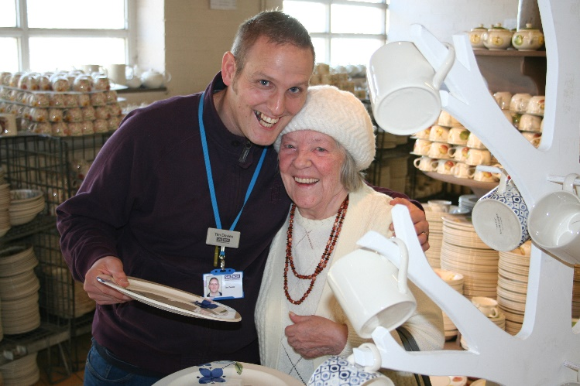

CareLink officer Tim and client Gwen enjoying some retail therapy
at the Royal Stafford Ceramic Café Heritage Trip February 2017
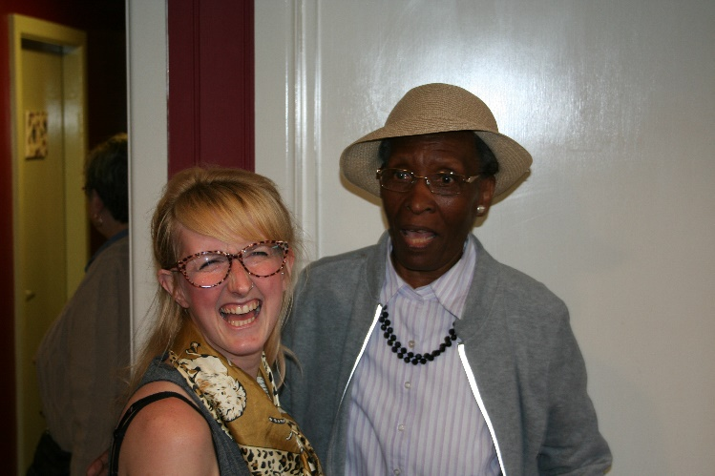

CareLink officer Charlotte and client Gertrude sharing a joke
(and a dance!) at the Emma Bridgewater Heritage trip June 2017

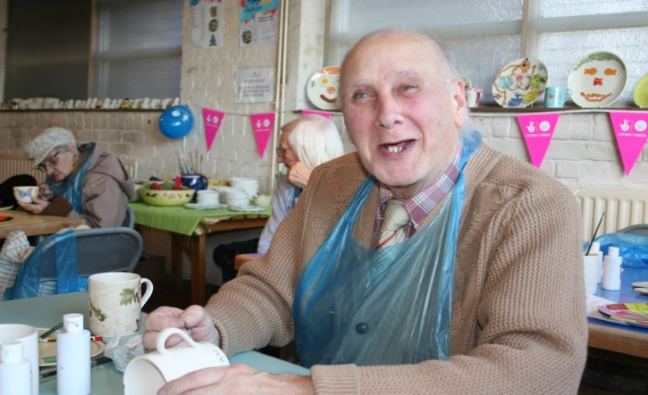

CareLink client Brian creating his ‘Tree of Life’ at Royal Stafford
Heritage Trip January 2017

Front Cover Photo: CareLink staff, clients and volunteers ‘team photo’
at the Port Vale FC Heritage Trip, May 2017.

